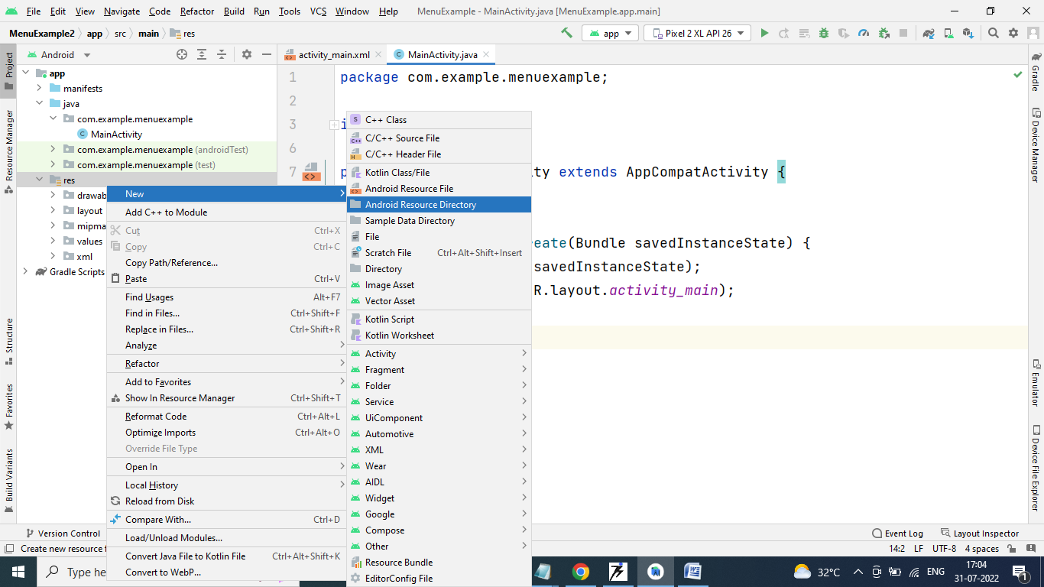

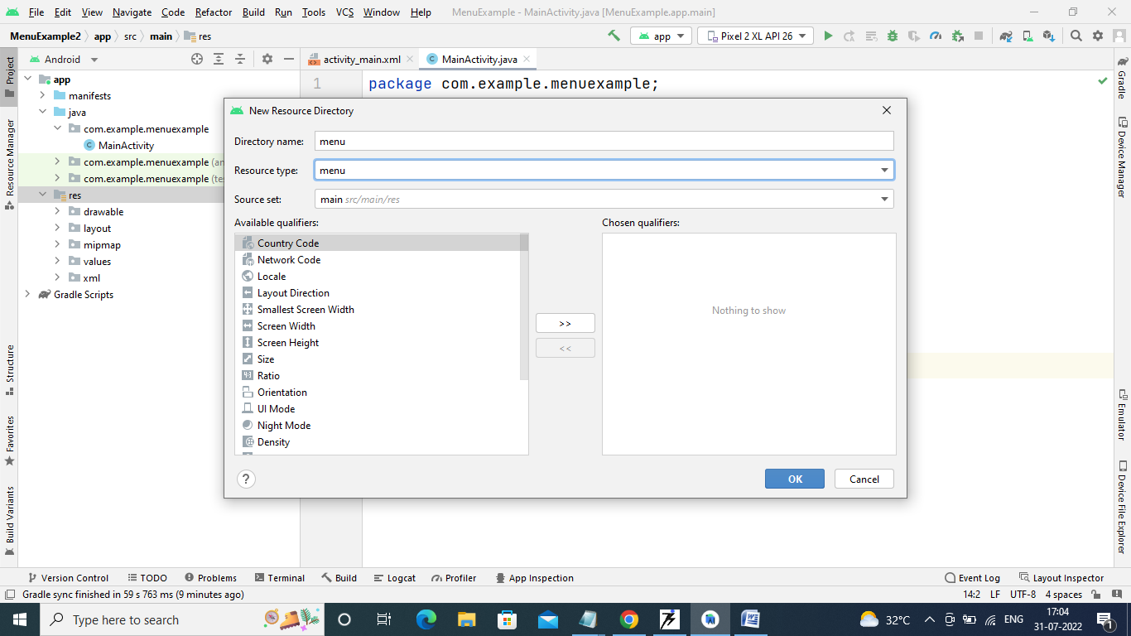

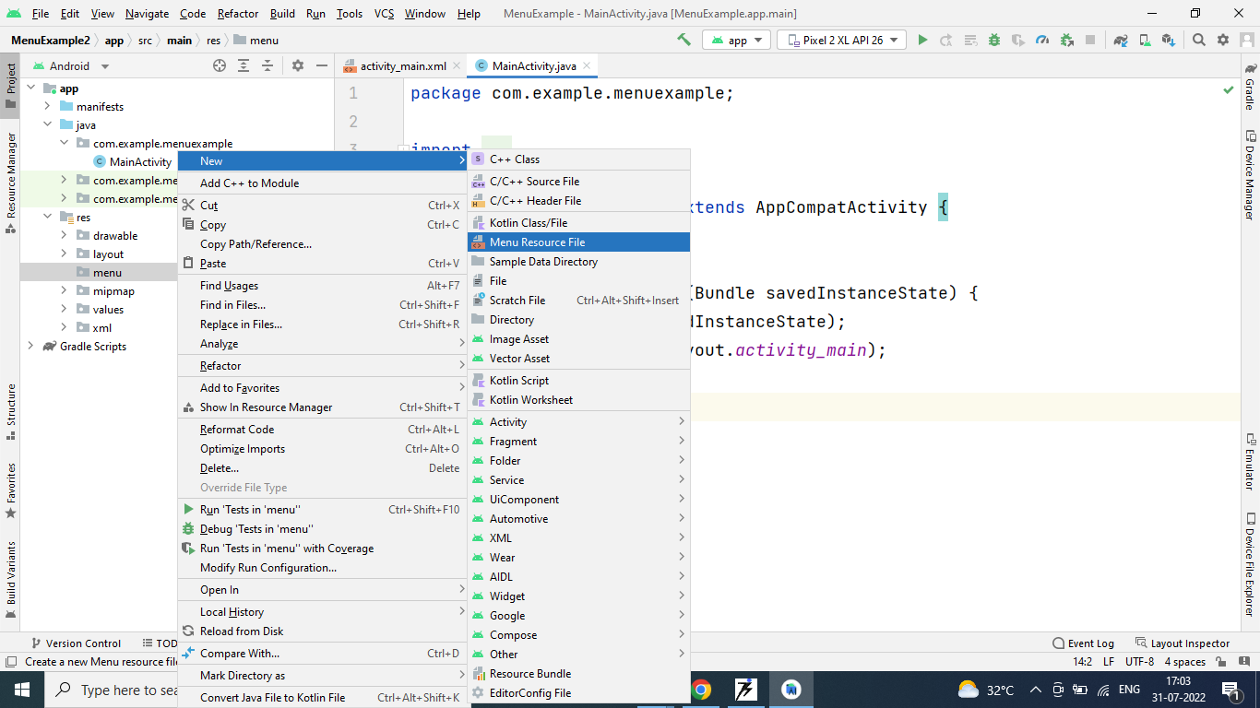

Sidemenu.xml

*<?*xml version="1.0" encoding="utf-8"*?>*<menu xmlns:android="http://schemas.android.com/apk/res/android"  
 xmlns:app="http://schemas.android.com/apk/res-auto">  
<item android:id="@+id/help"  
 android:title="Help"  
 app:showAsAction="never"/>  
  
 <item android:id="@+id/aboutus"  
 android:title="About Us"  
 app:showAsAction="never">  
 <menu>  
 <item android:id="@+id/subitemmca"  
 android:title="MCA"/>  
 <item android:id="@+id/subitemmsc"  
 android:title="MSc"/>  
 <item android:id="@+id/subitempgdca"  
 android:title="PGDCA"/>  
  
 </menu>  
 </item>  
  
 <item android:id="@+id/phone"  
 android:title="Phone"  
 android:icon="@drawable/phone"  
 app:showAsAction="ifRoom"/>  
  
 <item android:id="@+id/email"  
 android:title="E-mail"  
 android:icon="@drawable/email"  
 app:showAsAction="always"/>  
  
 <item android:id="@+id/sms"  
 android:title="SMS"  
 android:icon="@drawable/sms"  
 app:showAsAction="withText"/>  
  
 <item android:id="@+id/contactus"  
 android:title="Contact Us"  
 app:showAsAction="never"/>  
  
 <item android:id="@+id/exit"  
 android:title="Exit"  
 app:showAsAction="never"/>  
  
  
  
</menu>

MainActivity.java

package com.example.optionsmenuexample;  
  
import androidx.annotation.NonNull;  
import androidx.appcompat.app.AppCompatActivity;  
  
import android.content.Intent;  
import android.os.Bundle;  
import android.view.Menu;  
import android.view.MenuInflater;  
import android.view.MenuItem;  
import android.widget.Toast;  
  
public class MainActivity extends AppCompatActivity {  
  
 @Override  
 protected void onCreate(Bundle savedInstanceState) {  
 super.onCreate(savedInstanceState);  
 setContentView(R.layout.*activity_main*);  
  
 }  
  
  
 @Override  
 public boolean onCreateOptionsMenu(Menu menu) {  
 MenuInflater inflater = getMenuInflater();  
 inflater.inflate(R.menu.*sidemenu*, menu);  
 return true;  
 }  
  
 @Override  
 public boolean onOptionsItemSelected(@NonNull MenuItem item) {  
  
 switch(item.getItemId()){  
 case R.id.*help*:  
 Toast.*makeText*(this,"Help",Toast.*LENGTH_LONG*).show();  
 case R.id.*contactus*:  
 Toast.*makeText*(this,"Contact Us",Toast.*LENGTH_LONG*).show();  
 case R.id.*subitemmca*:  
 Intent imca= new Intent(MainActivity.this,MCA.class);  
 startActivity(imca);  
 case R.id.*exit*:  
 this.finish();  
  
 }  
 return super.onOptionsItemSelected(item);  
 }  
}

MCA.Java

package com.example.optionsmenuexample;  
  
import androidx.annotation.NonNull;  
import androidx.appcompat.app.ActionBar;  
import androidx.appcompat.app.AppCompatActivity;  
  
import android.content.Intent;  
import android.os.Bundle;  
import android.view.MenuItem;  
  
public class MCA extends AppCompatActivity {  
  
 @Override  
 protected void onCreate(Bundle savedInstanceState) {  
 super.onCreate(savedInstanceState);  
 setContentView(R.layout.*activity_mca*);  
  
 *// calling the action bar* ActionBar actionBar = getSupportActionBar();  
 *// Customize the back button* actionBar.setHomeAsUpIndicator(R.drawable.mybutton);  
  
 *// showing the back button in action bar* actionBar.setDisplayHomeAsUpEnabled(true);  
 }  
  
 @Override  
 public boolean onOptionsItemSelected(@NonNull MenuItem item) {  
 switch(item.getItemId()){  
 case android.R.id.*home*:  
 Intent mainactivity= new Intent(MCA.this, MainActivity.class);  
 startActivity(mainactivity);  
 return true;  
 }  
 return super.onOptionsItemSelected(item);  
 }  
  
}

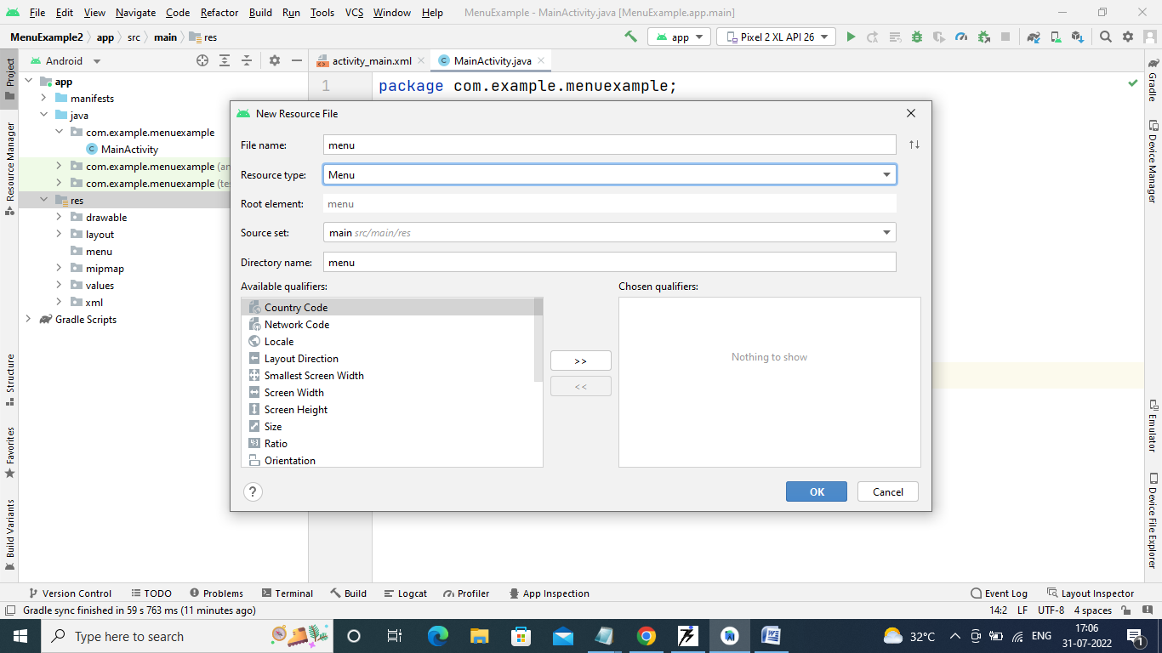

MainActivity.java

package com.example.optionsmenuexample;  
  
import androidx.annotation.NonNull;  
import androidx.appcompat.app.AppCompatActivity;  
  
import android.content.Intent;  
import android.os.Bundle;  
import android.view.Menu;  
import android.view.MenuInflater;  
import android.view.MenuItem;  
import android.widget.Toast;  
  
public class MainActivity extends AppCompatActivity {  
  
 @Override  
 protected void onCreate(Bundle savedInstanceState) {  
 super.onCreate(savedInstanceState);  
 setContentView(R.layout.*activity_main*);  
  
 }  
  
 @Override  
 public boolean onCreateOptionsMenu(Menu menu) {  
 MenuInflater inflater = getMenuInflater();  
 inflater.inflate(R.menu.*sidemenu*, menu);  
 return true;  
 }  
  
 @Override  
 public boolean onOptionsItemSelected(@NonNull MenuItem item) {  
 switch(item.getItemId()){  
 case R.id.*help*:  
 Toast.*makeText*(this,"Help",Toast.*LENGTH_LONG*).show();  
 case R.id.*contactus*:  
 Toast.*makeText*(this,"Contact Us",Toast.*LENGTH_LONG*).show();  
 case R.id.*subitemmca*:  
 Intent imca= new Intent(MainActivity.this,MCA.class);  
 startActivity(imca);  
 case R.id.*exit*:  
 this.finish();  
  
 }  
 return super.onOptionsItemSelected(item);  
 }  
}

………………………………………………………………………………………………………………………………………..

Sidemenu.xml

*<?*xml version="1.0" encoding="utf-8"*?>*<menu xmlns:android="http://schemas.android.com/apk/res/android"  
 xmlns:app="http://schemas.android.com/apk/res-auto">  
<item android:id="@+id/help"  
 android:title="Help"  
 app:showAsAction="never"/>  
  
 <item android:id="@+id/aboutus"  
 android:title="About Us"  
 app:showAsAction="never">  
 <menu>  
 <item android:id="@+id/subitemmca"  
 android:title="MCA"/>  
 <item android:id="@+id/subitemmsc"  
 android:title="MSc"/>  
 <item android:id="@+id/subitempgdca"  
 android:title="PGDCA"/>  
  
 </menu>  
 </item>  
  
 <item android:id="@+id/phone"  
 android:title="Phone"  
 android:icon="@drawable/phone"  
 app:showAsAction="ifRoom"/>  
 <item android:id="@+id/email"  
 android:title="E-mail"  
 android:icon="@drawable/email"  
 app:showAsAction="always"/>  
 <item android:id="@+id/sms"  
 android:title="SMS"  
 android:icon="@drawable/sms"  
 app:showAsAction="withText"/>  
  
  
  
  
  
 <item android:id="@+id/contactus"  
 android:title="Contact Us"  
 app:showAsAction="never"/>  
  
 <item android:id="@+id/exit"  
 android:title="Exit"  
 app:showAsAction="never"/>  
  
  
  
</menu>

…………………………………………………………………………………………………………………………………………

Create Any other activity to be connected, in this case MCA

……………………………………………………………………………………………………………………………………

Activity_mca.xml

*<?*xml version="1.0" encoding="utf-8"*?>*<LinearLayout  
 xmlns:android="http://schemas.android.com/apk/res/android"  
 xmlns:app="http://schemas.android.com/apk/res-auto"  
 xmlns:tools="http://schemas.android.com/tools"  
 android:layout_width="match_parent"  
 android:layout_height="match_parent"  
 android:gravity="center"  
 tools:context=".MCA">  
<Button  
 android:layout_width="wrap_content"  
 android:layout_height="wrap_content"  
 android:text="GDCST MCA Sem III"  
  
 />  
</LinearLayout>

………………………………………………

Mca.java

package com.example.optionsmenuexample;  
  
import androidx.annotation.NonNull;  
import androidx.appcompat.app.ActionBar;  
import androidx.appcompat.app.AppCompatActivity;  
  
import android.content.Intent;  
import android.os.Bundle;  
import android.view.MenuItem;  
  
public class MCA extends AppCompatActivity {  
  
 @Override  
 protected void onCreate(Bundle savedInstanceState) {  
 super.onCreate(savedInstanceState);  
 setContentView(R.layout.*activity_mca*);  
  
 *// calling the action bar* ActionBar actionBar = getSupportActionBar();  
 *// Customize the back button  
// actionBar.setHomeAsUpIndicator(R.drawable.mybutton);  
  
 // showing the back button in action bar* actionBar.setDisplayHomeAsUpEnabled(true);  
 }  
  
 @Override  
 public boolean onOptionsItemSelected(@NonNull MenuItem item) {  
 switch(item.getItemId()){  
 case android.R.id.*home*:  
 Intent mainactivity= new Intent(MCA.this, MainActivity.class);  
 startActivity(mainactivity);  
 return true;  
 }  
 return super.onOptionsItemSelected(item);  
 }  
  
  
}